SQL AP 2
Requête 1 :
SELECT nom
FROM Lieu
WHERE ile = 1

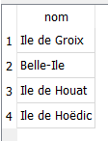

Requête 2 :
SELECT DISTINCT Lieu.nom
FROM Lieu
JOIN Port ON Lieu.id = Port.idLieu
JOIN Trajet ON Port.id = Trajet.idPortArrivee
WHERE Trajet.idPortDepart = 2
AND Lieu.ile = 1;


Requête 3 :
SELECT DISTINCT Port.nom, Port.adresse
FROM Port
JOIN Lieu ON Lieu.id = Port.idLieu
WHERE Lieu.id = 1
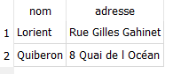

Requête 4 :
SELECT PortDepart.nom AS PortDepart, PortArrivee.nom AS PortArrivee
FROM Trajet
JOIN Port AS PortDepart ON Trajet.idPortDepart = PortDepart.id
JOIN Port AS PortArrivee On Trajet.idPortArrivee = PortArrivee.id
Join Lieu AS LieuA ON PortArrivee.idLieu = LieuA.id
WHERE LieuA.id = 3

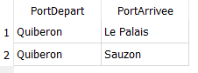

Requête 5 :
SELECT Bateau.nom AS nomB, utiliser.duree AS duree
FROM Trajet
JOIN utiliser ON utiliser.idTrajet = Trajet.id
JOIN Bateau ON utiliser.idBateau = Bateau.id
JOIN Port AS PortDepart ON PortDepart.id = Trajet.idPortDepart
JOIN Port AS PortArrivee ON PortArrivee.id = Trajet.idPortArrivee
JOIN Lieu AS LieuDepart ON LieuDepart.id = PortDepart.id
JOIN Lieu AS LieuArrivee ON LieuArrivee.id = PortArrivee.id
WHERE LieuDepart.id = 2
OR LieuArrivee.id = 2

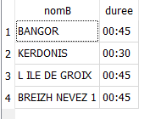

Requête 6 :
SELECT nom, vitesse
FROM Bateau
ORDER BY vitesse DESC
LIMIT 1
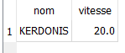

Requête 7 :
SELECT pd.nom AS PortDepart, pa.nom AS PortArrivee, utiliser.duree
FROM Trajet
JOIN utiliser ON Trajet.id = utiliser.idTrajet
JOIN Port AS pd ON pd.id = Trajet.idPortDepart
JOIN Port AS pa ON pa.id = Trajet.idPortArrivee
